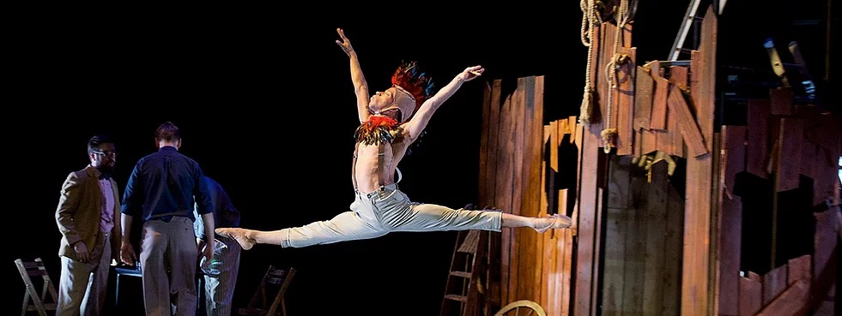
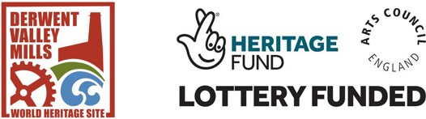

Call for professional dancers:
Spin A Tale & Darley Abbey Day 2021

An opportunity to be involved in a unique event inspired by the heritage of Darley Abbey, Derbyshire

Constella OperaBallet are looking for 4 professional dancers, with a background in ballet and contemporary styles, to take part in a filming project, as part of the company’s imaginative and original offerings for Darley Abbey Day 2021! This project is in conjunction with Derwent Valley Mills World Heritage Site Great Place Scheme and Beam, thanks to funding from the National Lottery Heritage Fund and Arts Council England.
​
As part of Constella’s involvement we will be rehearsing and filming performances, under Covid-safe conditions and following Government guidelines, on 7th & 8th April on location in Darley Abbey. The short films will then form our virtual offering for Darley Abbey Day, taking place on 8th May 2021.

Successful dancers will be taking part in ‘Water Hymn’, a 5-minute long dance piece based on the movement of water, choreographed by Sarah-Louise Kristiansen, to music composed by Leo Geyer.
​
The plan
​
- Successful candidates will be sent a series of videos from our choreographer, in advance. It is expected that the dancers will learn the choreography for the piece in advance of filming.
- An in-person, socially-distanced and Covid-safe, rehearsal will take place in the afternoon of 7th April 2021 on location in Darley Abbey.
- Filming will then take place on 8th April 2021, also in Darley Abbey, exact timings to be confirmed.
- A fee of £100 will be provided to each dancer to cover these two dates.
What we’d like from you
​
Experience of outdoor performance is desirable, and a willingness to express your creativity essential! Candidates must have proximity to, or a close connection with, South Derbyshire, and be able to provide their own transport to and from Darley Abbey on both dates (the village is a 25-minute walk from Derby City Centre).
​
If this sounds like you, please send an email to our producer Alice at alice.bezant@constella.org.uk , with a CV and video, no longer than 2 minutes, of you performing before 28th March 2021.

More information about the projects can be found at www.constella.org.uk and www.derwentvalleymills.org/spin-a-tale-2021/ .
​
Constella OperaBallet strives to provide a safe and inclusive environment for all, and we welcome applications from under-represented communities, particularly those from ethnically diverse backgrounds.

